# Practical 5

**Aim: Installation and Configuration of virtualization using KVM.**

Step 1 :#sudogrep -c "svm\|vmx" /proc/cpuinfo

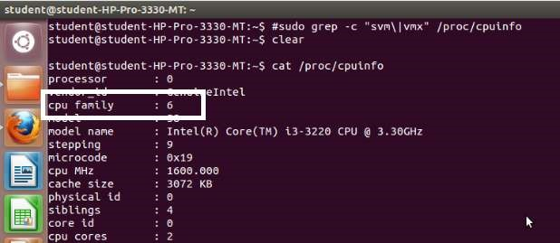

#### Step 2 :#sudo apt-get install qemu-kvmlibvirt-bin bridgeutilsvirt-manager

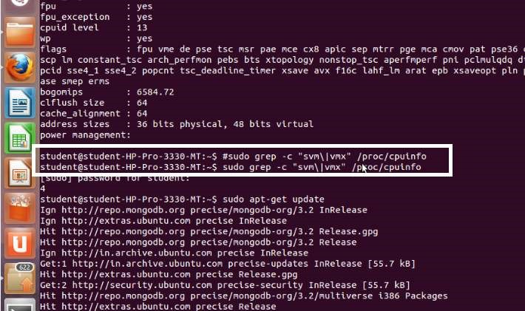

Step 3 :#sudoadduserrait

After running this command, log out and log back in as rait

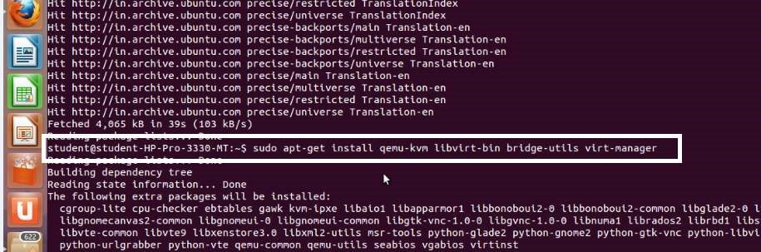

Step 4 :#sudoadduserraitlibvirtd

After running this command, log out and log back in as rait

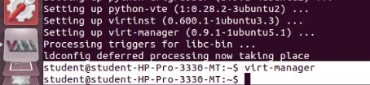

Step 5 :Open Virtual Machine Manager application and Create Virtual

Machine

#virt-manager as shown below

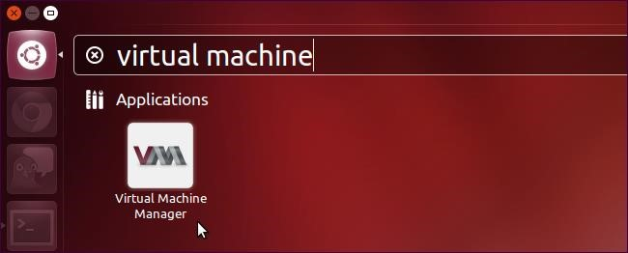

Step 6 : Create a new virtual machine as shown below

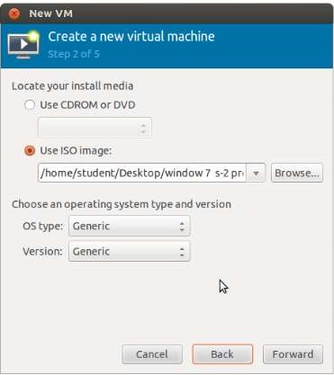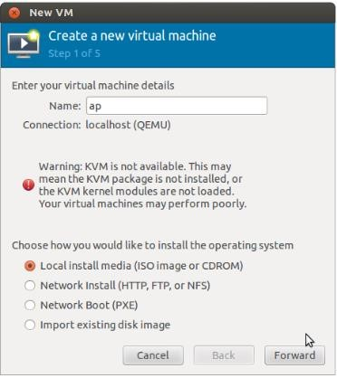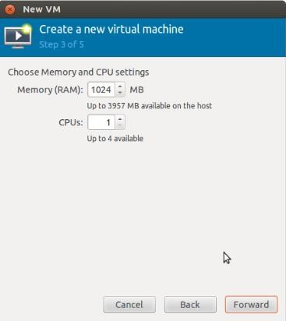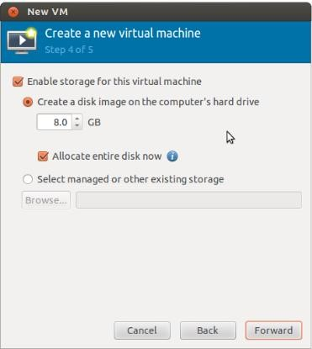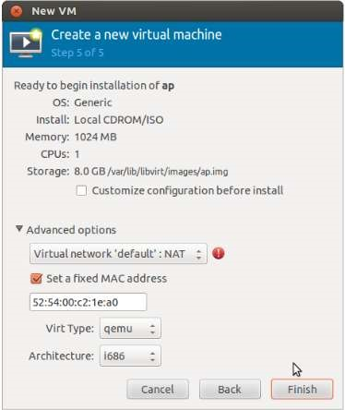

Step 7: Installation of windows 7 on virtual machine.

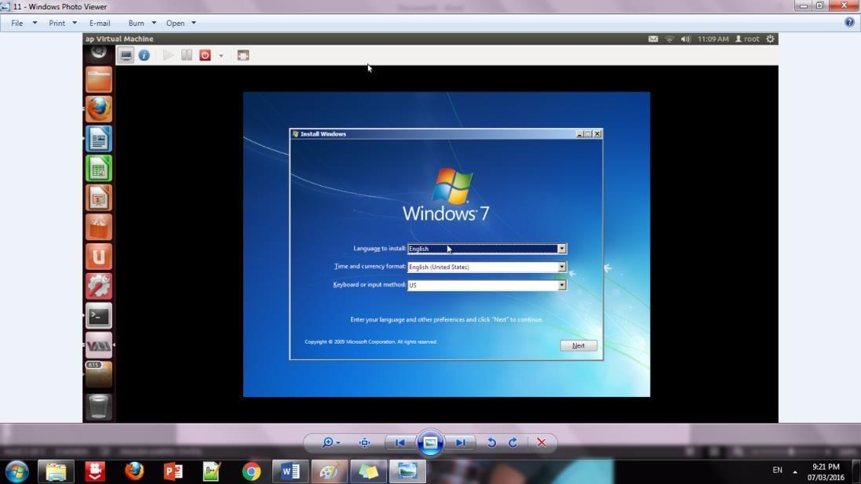

Step 10: Initialization of windows on virtual machine

